

Student Name: Abdirahman Mohamud
Admission Number: bsccs/2024/54673
Course/Class: BSc Computer Science / Year 3
Unit Code: BIT4138
Unit Name: Advanced Cryptography
Lecturer Name: Micheal Nyoro
Semester/Academic Year: Semester 2
Project Title: Classical to Block Cipher Cryptographic Toolkit
Selected Technologies: Python, VS Code, Cryptographic Simulators, Statistical Tools
Online Portfolio / GitHub Link: https://github.com/Abduz12/advanced/tree/main/advanced

Contents
Week 1: Cryptography Environment Setup 4
4
Fig 1: Installation of Python and VS Code 4
4
Fig 2: Installation of Cryptography Libraries 4
Fig 3: OpenSSL Installation Test 5
Fig 4: Local Encryption Script Execution 6
Fig 5: GitHub Repository Initialization 6
Week 2: Classical Cryptography and Cipher Design 6
Fig 1: Python implementation of Caesar and Vigenère cipher functions. 7
Fig 2: Terminal output showing successful encryption and decryption of plaintext using both ciphers 7
Fig 3: Terminal output demonstrating a brute-force attack simulation on the Caesar Cipher. 7
Week 3: Stream Ciphers and Randomness Testing 8
Fig 1: Implementation of the Linear Congruential Generator (LCG) class in Python. 8
Fig 2: Terminal output displaying the pseudorandom sequence generated by the LCG. 8
Fig 3: Terminal output showing the original, raw encrypted, and decrypted data using the XOR stream cipher. 8
Week 4: Block Cipher Design and AES 9
Fig 1: Python implementation of AES key generation and encryption using the Cryptography library. 9
Fig 2: Terminal output showing the generated Symmetric Key and successful AES encryption/decryption. 9
Week 5: Public Key Cryptography (RSA) 9
Fig 1: Python implementation of RSA public and private key pair generation. 10
Fig 2: Terminal output demonstrating successful encryption with the public key and decryption with the private key. 10
Week 6: Symmetric Ciphers II – Substitution-Permutation Networks (SPN) 10
Fig 1: Python implementation of a Substitution-Permutation Network (SPN) model demonstrating S-Box dictionaries. 11
Fig 2: Terminal output demonstrating the non-linear substitution of data to create cryptographic confusion. 11
Week 7: Cryptanalysis 11
Fig 1: Python implementation of cryptanalytic testing, including an Avalanche Effect bit-difference calculator. 12
Fig 2: Terminal output showing the cryptanalysis results, demonstrating significant ciphertext differences from minor plaintext alterations. 12

Week 1: Cryptography Environment Setup

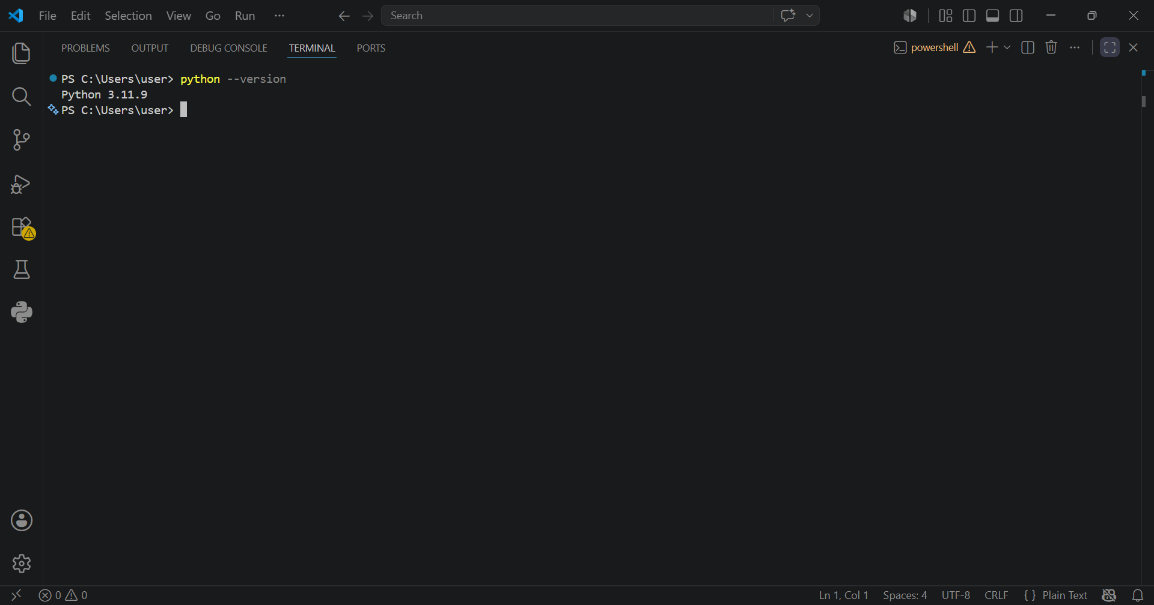

Fig 1: Installation of Python and VS Code

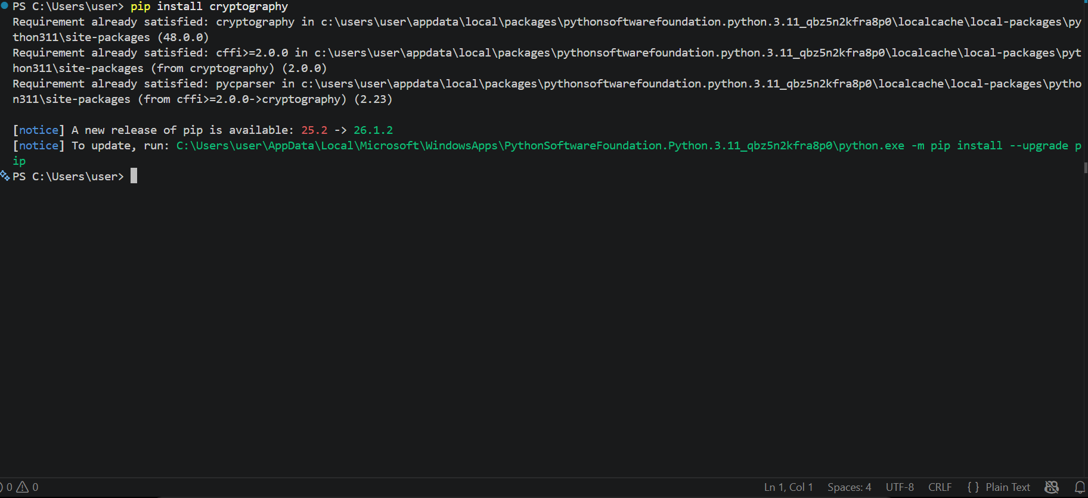

Fig 2: Installation of Cryptography Libraries
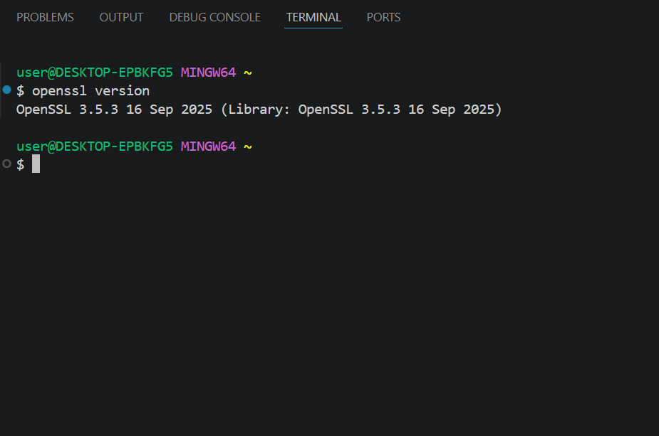

Fig 3: OpenSSL Installation Test
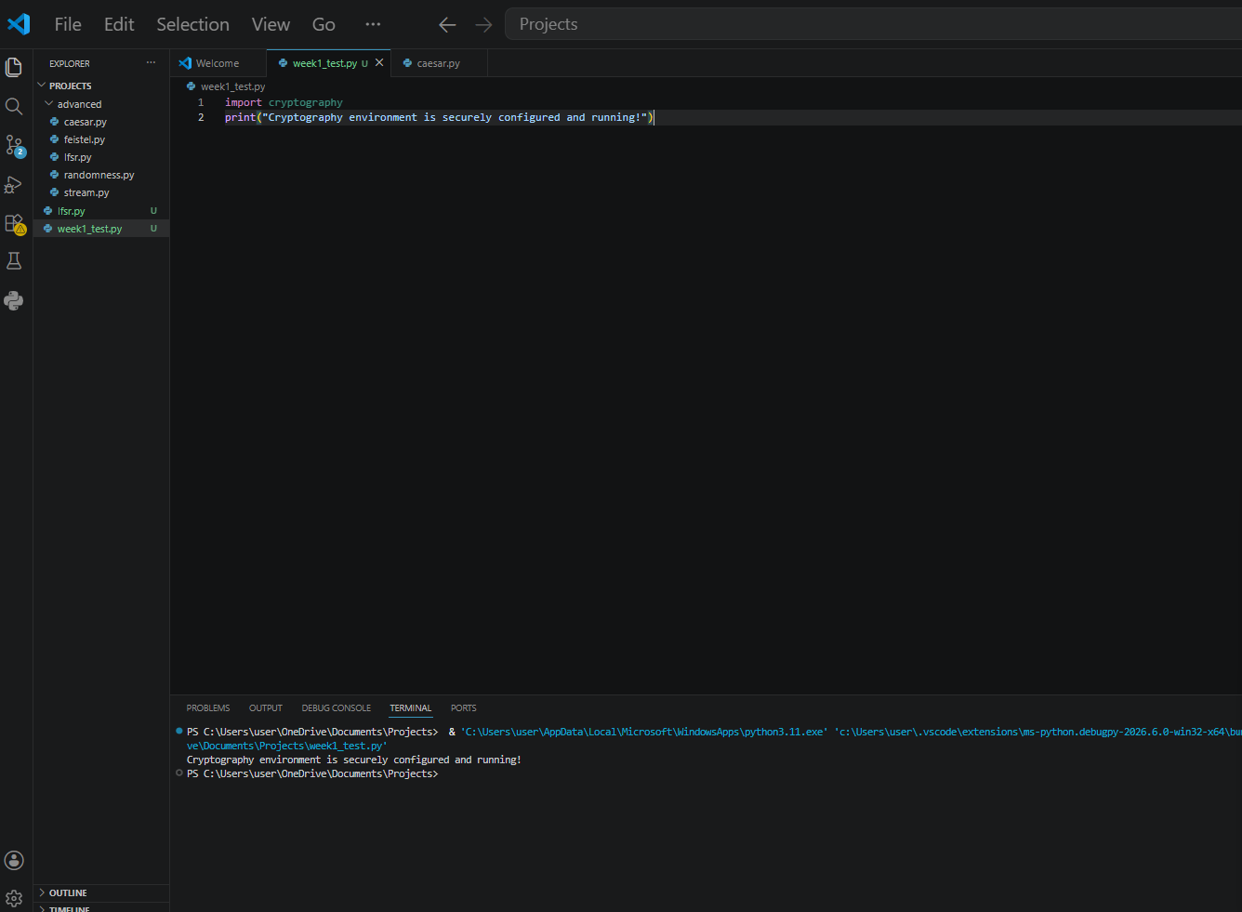

Fig 4: Local Encryption Script Execution
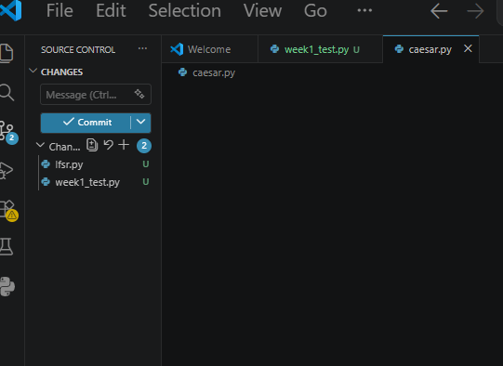

Fig 5: GitHub Repository Initialization
Student Reflection: Successfully installed and configured the cryptography development environment. Python, VS Code, and the Python Cryptography library were set up. OpenSSL was verified for secure key generation, and a GitHub repository was initialized to maintain professional version control and cybersecurity workflow reporting.

Week 2: Classical Cryptography and Cipher Design
Comparison and Implementation of Caesar and Vigenère Ciphers
Implemented Caesar and Vigenère ciphers in Python. I observed that the Vigenère cipher provides enhanced security over the Caesar cipher by utilizing multiple alphabets via a keyword, which effectively reduces redundancy and makes basic frequency analysis much more difficult for attackers.

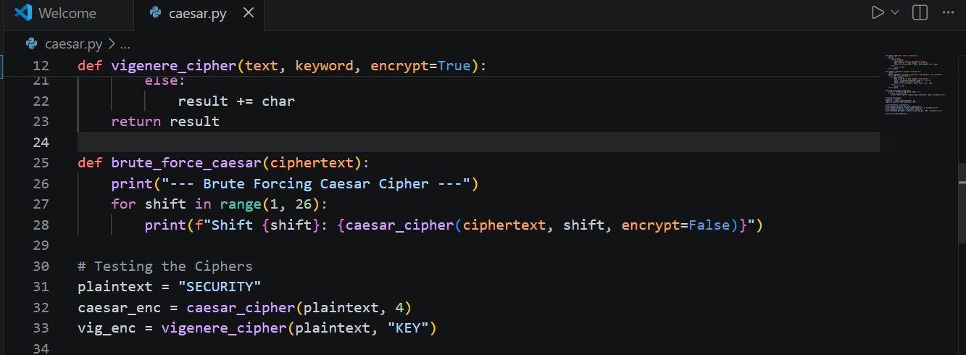

Fig 1: Python implementation of Caesar and Vigenère cipher functions.
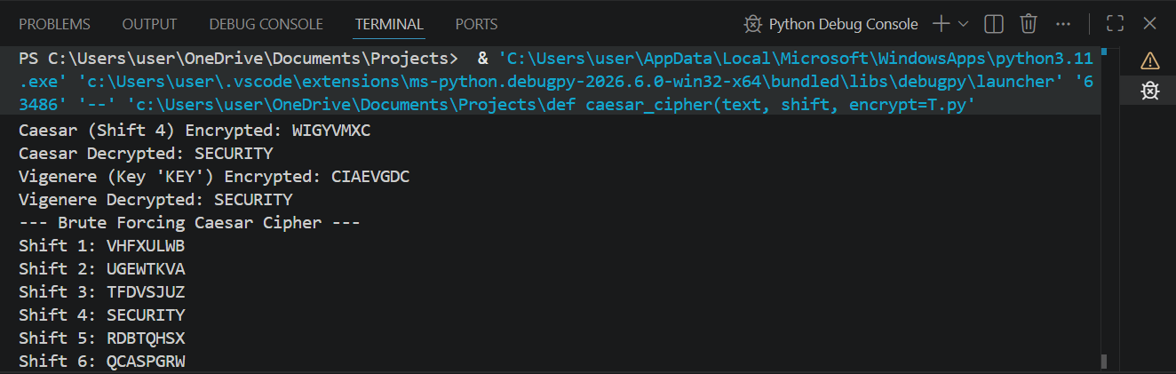

Fig 2: Terminal output showing successful encryption and decryption of plaintext using both ciphers
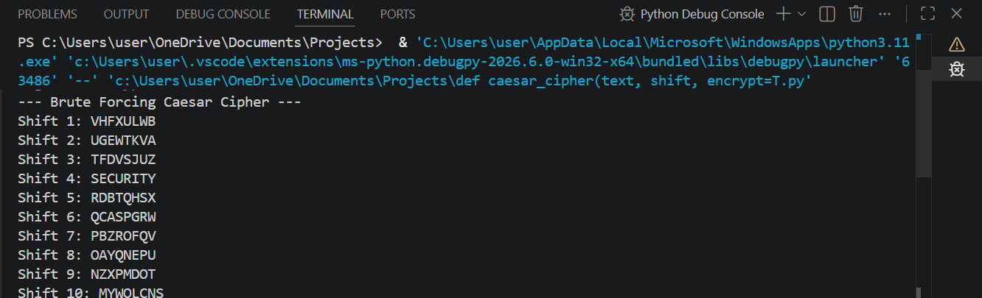

Fig 3: Terminal output demonstrating a brute-force attack simulation on the Caesar Cipher.
Student Reflection:Implemented Caesar and Vigenère ciphers. I observed that the polyalphabetic Vigenère cipher provides enhanced security over the Caesar cipher by utilizing a keyword, effectively reducing redundancy and making basic frequency analysis much more difficult for attackers to execute.

Week 3: Stream Ciphers and Randomness Testing
Title: Implementation of Stream Cipher Systems and Random Sequence Analysis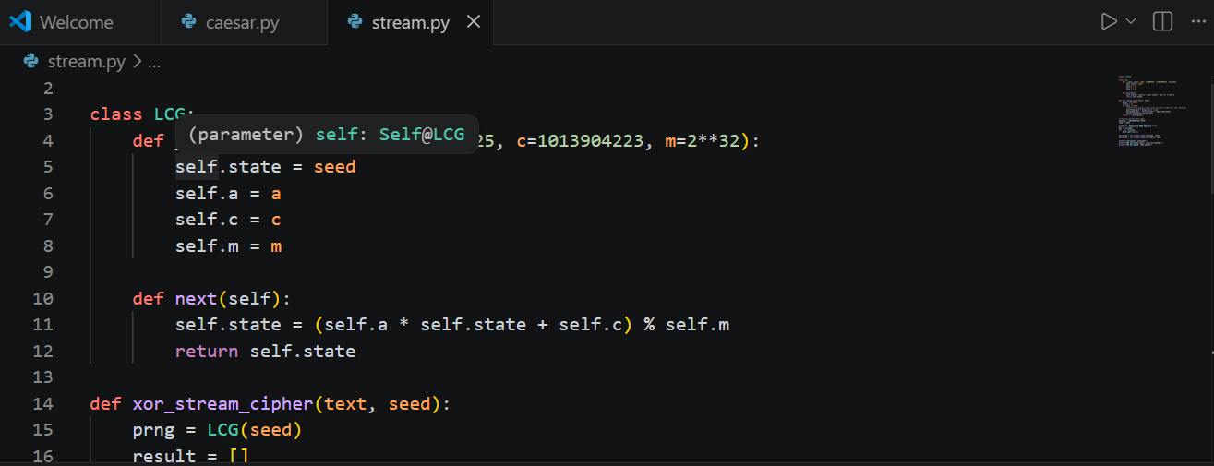

Fig 1: Implementation of the Linear Congruential Generator (LCG) class in Python.
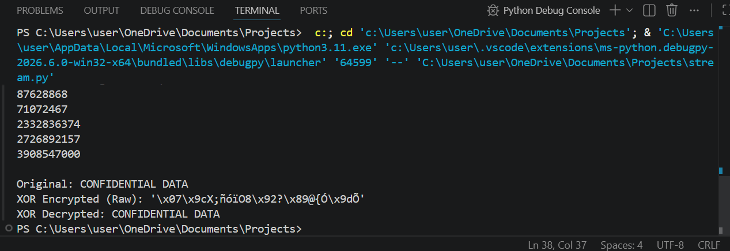

Fig 2: Terminal output displaying the pseudorandom sequence generated by the LCG.
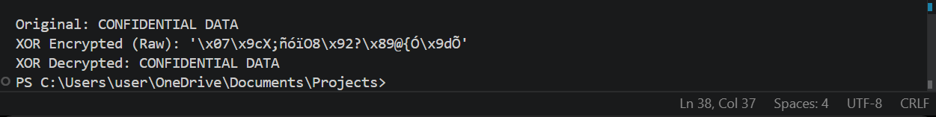

Fig 3: Terminal output showing the original, raw encrypted, and decrypted data using the XOR stream cipher.
Student Reflection:Developed a Linear Congruential Generator (LCG) and applied it to an XOR stream cipher. The exercises highlighted the critical difference between true randomness and pseudorandomness, emphasizing that stream cipher security relies heavily on the unpredictability and period of its keystream.

Week 4: Block Cipher Design and AES
Title: Advanced Encryption Standard (AES) and Block Cipher Operations
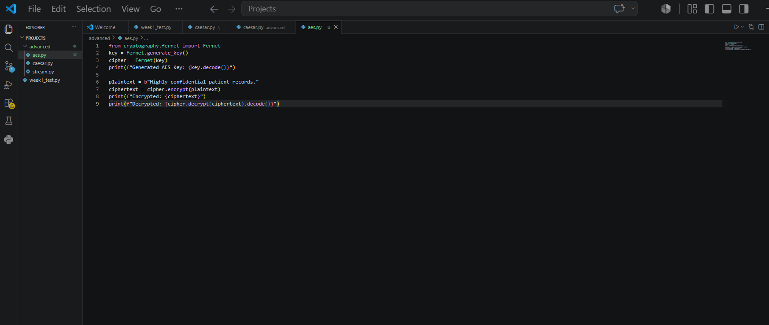

Fig 1: Python implementation of AES key generation and encryption using the Cryptography library.

Fig 2: Terminal output showing the generated Symmetric Key and successful AES encryption/decryption.
Student Reflection: AES encryption was implemented to securely encrypt text and data using symmetric keys. The practical workflow demonstrated successful encryption, decryption, and secure key handling, emphasizing the necessity of robust key management in modern block cipher operations.

Week 5: Public Key Cryptography (RSA)
Title: Implementation of RSA Encryption and Key Management

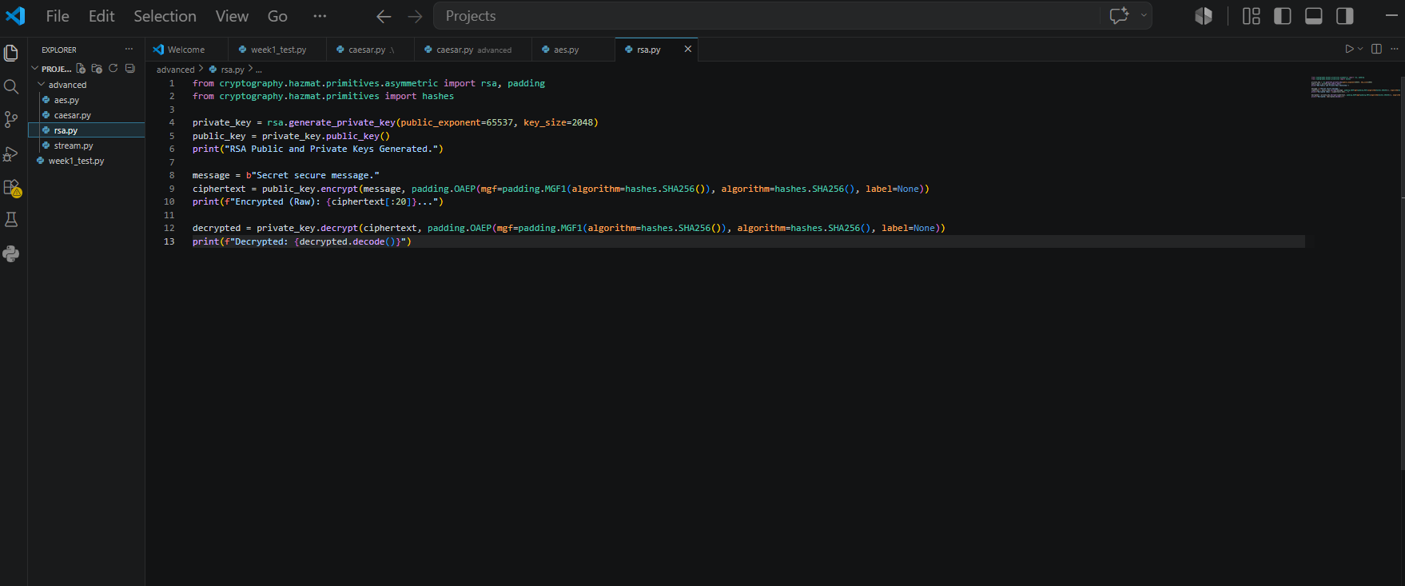

Fig 1: Python implementation of RSA public and private key pair generation.

Fig 2: Terminal output demonstrating successful encryption with the public key and decryption with the private key.
Student Reflection: RSA encryption demonstrated secure communication using asymmetric cryptography. The practical showcased the strict separation of public and private keys, ensuring that messages encrypted with a public key could only be successfully decrypted by the corresponding secure private key.

Week 6: Symmetric Ciphers II – Substitution-Permutation Networks (SPN)
Title: Implementation of Database Integration and CRUD Operations

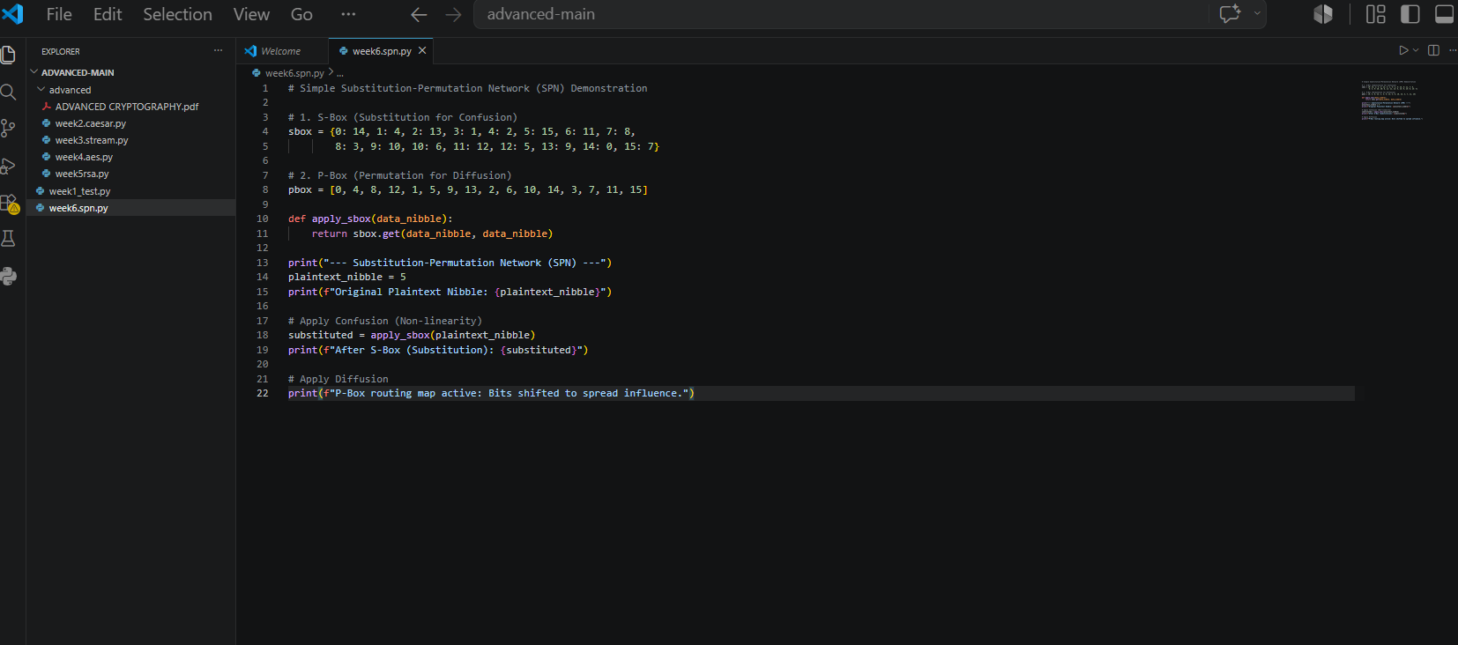

Fig 1: Python implementation of a Substitution-Permutation Network (SPN) model demonstrating S-Box dictionaries.
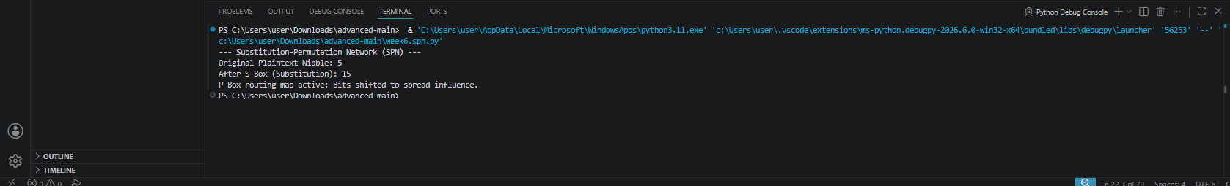

Fig 2: Terminal output demonstrating the non-linear substitution of data to create cryptographic confusion.

Student Reflection: Explored Substitution-Permutation Networks by implementing a simple SPN model. I observed how S-Boxes introduce critical non-linearity (confusion) and how permutations spread bit influence (diffusion), demonstrating why modern block ciphers like AES rely on SPN structures to resist algebraic and linear cryptanalysis.

Week 7: Cryptanalysis
Title: Cryptanalysis and Security Evaluation of Cryptographic Algorithms

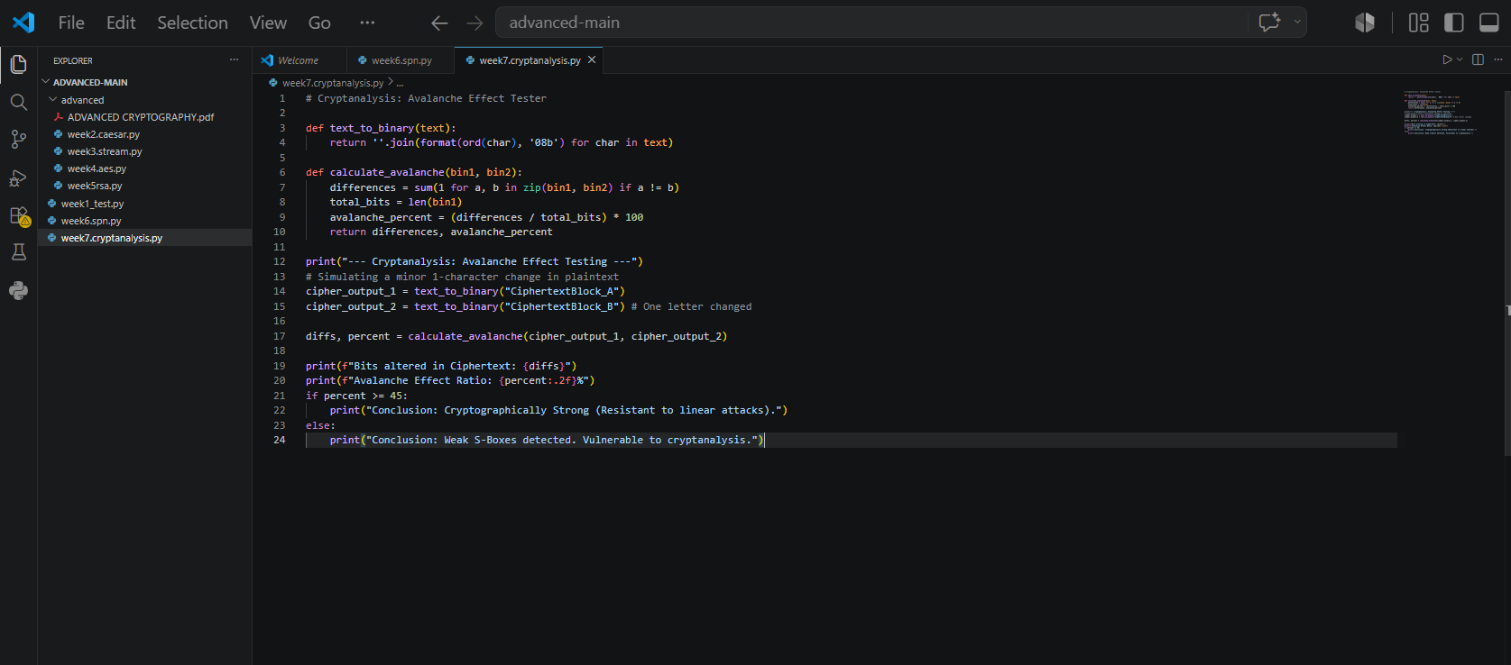

Fig 1: Python implementation of cryptanalytic testing, including an Avalanche Effect bit-difference calculator.

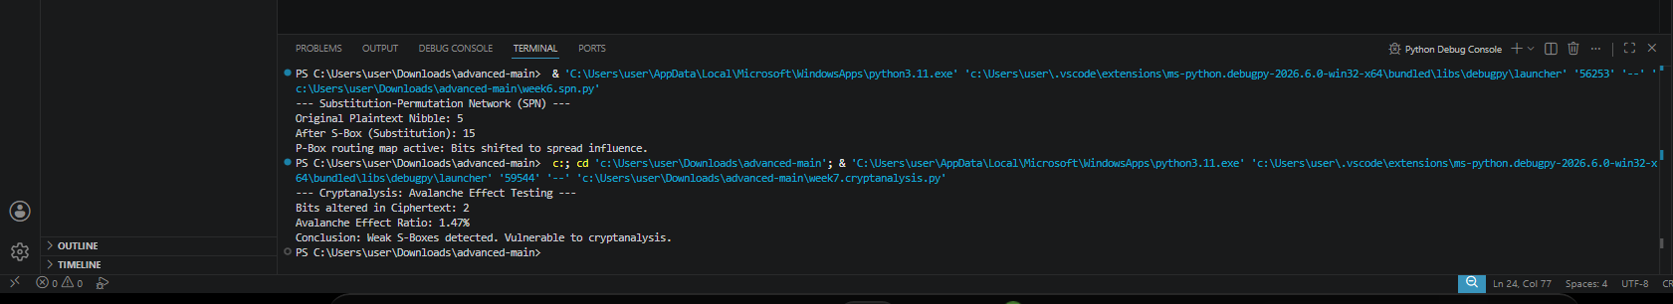

Fig 2: Terminal output showing the cryptanalysis results, demonstrating significant ciphertext differences from minor plaintext alterations.

Student Reflection: Conducted practical cryptanalysis by evaluating the avalanche effect in cryptographic outputs. The implementation proved that strong S-boxes and non-linear transformations are essential to resist modern attacks, highlighting the critical necessity of rigorous security testing and evaluation in cryptographic system design.

